Topic 3 – 5 – Analyzing Graph features – Teaching Set 2
1). Consider $f\left(x\right)=\frac{1}{1+2^{8x}}$ Don’t use technology; just your mind.
a). As $x→∞$, $f\left(x\right)→$ _______ ? b). As $x→-∞$, $f\left(x\right)→$ ______ ?
c). What graph feature are parts a and b relevant for thinking about?
d). What’s the y-intercept?
e). Make your best sketch of the graph of $y=f\left(x\right)$ based on what you’ve written down.

2). Here’s a table of values for a function $f(x)$ and another function $g(x)$.
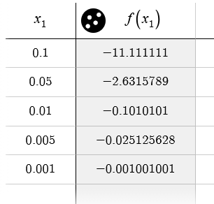
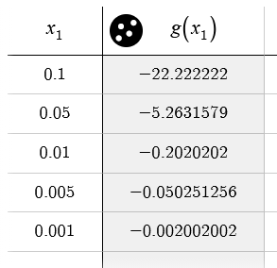
$$x$$
$$f(x)$$
$$x$$
$$g(x)$$

a). Based on the evidence, do you think that $y=\frac{1}{f(x)}$ has a vertical asymptote at x = 0? If so, explain why. If not, say what is happening there.
b). Based on the evidence, do you think that $y=\frac{1}{f\left(x\right) + g(x)}$ has a vertical asymptote at x = 0? If so, explain why. If not, say what is happening there.
c). Based on the evidence, do you think that $y=\frac{f(x)}{g(x)}$ has a vertical asmptote at x = 0? If so, explain why. If not, say what is happening there.

3). Here’s a graph of $y=f(x)$.
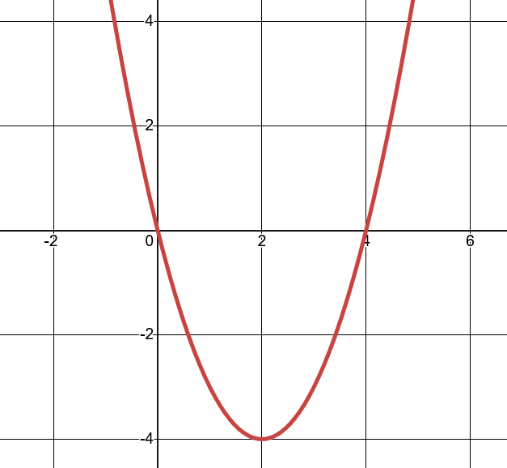
I’m going to ask you questions about $g(x)=\frac{1}{f(x)}$
a). Does g(x) have any vertical asymptotes? If so, where? If not, why not?
b). As $x→∞$, $g\left(x\right)→$ _____ ?
As $x→-∞$, $g\left(x\right)→$____ ?
c). What point on g(x) corresponds to the point (2, -4) on the graph?
d). Make your best sketch of $y=g(x)$ based on your answers above.

Topic 3 – 5 – Analyzing Graph features – Teaching Set 2 – Solutions
1). Consider $f\left(x\right)=\frac{1}{1+2^{8x}}$
a). What happens as $x→∞$ ? Imagine plugging in larger and larger x-values. You don’t actually have to do it; just imagine the kind of trend that will happen. You’ll get $\frac{1}{large \#'s}$ . The larger the value of x, the larger the denominator, which means the closer the entire number is to 0. Therefore, as $x→∞$, $f\left(x\right)→$ 0 .
b). As $x→-∞$ we imagine plugging in larger and larger negative numbers. Let’s do just one: $\frac{1}{1+2^{-80000000}}$. This is the same as: $\frac{1}{1+\frac{1}{2^{80000000}}}$ which is like $\frac{1}{1+(almost 0)}≈1$. Hopefully you can imagine the trend. The larger the negative number the closer $2^{8x}$ gets to 0, which means the closer $\frac{1}{1+2^{8x}}$ gets to 1. Therefore, as $x→-∞$, $f\left(x\right)→1$.
c). When we ask about the trend in y-values as $x→∞$, we’re investigating “end-behavior”. Literally: what’s happening at the ends of functions (even though, of course, they don’t really have and ending point). Since we saw that the y-values are approaching a fixed y-value, that tells us there are horizontal asymptotes. In fact, there are different horizontal asymptotes as $x→∞$ and as $x→-∞$. What does that look like? Check out the graph below.
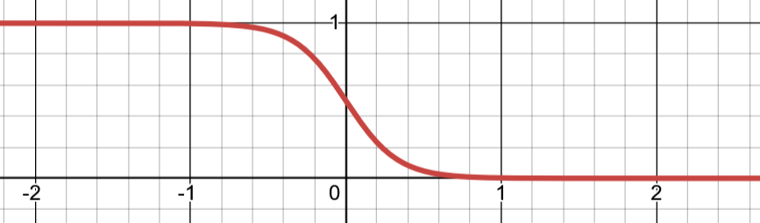
c). The y-intercept is when x = 0. Plugging in x = 0 we get: $\frac{1}{1+2^{0}}=\frac{1}{1+1}=\frac{1}{2}$.
d). Make your best sketch of the graph of $y=f\left(x\right)$ based on what you’ve written down.

2). Here’s a table of values for a function $f(x)$ and another function $g(x)$.


$$x$$
$$f(x)$$
$$x$$
$$g(x)$$

a). Based on the evidence, do you think that $y=\frac{1}{f(x)}$ has a vertical asymptote at x = 0?
It sure looks that way. As $x→0$, the $f(x)$ values are also approaching 0. That means $y=\frac{1}{(values approaching 0)}=values approaching ∞$. As the denominator gets closer to 0, the overall fraction goes to infinity. That means the shape of the function will look like a vertical spike upward that approaches a vertical line at $x=0$. In other words, a vertical asymptote.
b). Based on the evidence, do you think that $y=\frac{1}{f\left(x\right) + g(x)}$ has a vertical asymptote at x = 0? If so, explain why. If not, say what is happening there.
Also yes. Just imagine adding the $f(x)$ and $g\left(x\right)$ values for each row of the table. Again, no need to actually do it, just imagine. The $f(x)$ values are getting closer to 0, and the $g(x)$ values are getting closer to 0, so the $f\left(x\right)+g(x)$ values are also getting closer to 0. So the same analysis as the last problem applies.
c). Based on the evidence, do you think that $y=\frac{f(x)}{g(x)}$ has a vertical asmptote at x = 0? If so, explain why. If not, say what is happening there.
Here the answer is no. Remember that a vertical asymptote only happens if the function’s y-values are going to $∞$ or $-∞$ as the x-values approach a specific place. Let’s just look at the bottom row of the table where x is very close to 0. At $x=0.001$, the y-value is $\frac{f\left(0.001\right)}{g(0.001)}=\frac{-0.001001001}{-0.002002002}=\frac{1}{2}$. That certainly doesn’t look like it’s going to infinity or negative infinity. If you check some other values, you’ll see that $g(x)$ is always twice as big as $f(x)$. So actually, it looks like the y-values make a horizontal line at $y=\frac{1}{2}$ .
Of course, based on just these values we can’t be totally sure. It’s possible to construct functions that have these values, but are doing other things in between. But based on the evidence, I think this is a reasonable guess about what’s probably happening.
3). Here’s a graph of $y=f(x)$.

I’m going to ask you questions about $g(x)=\frac{1}{f(x)}$
a). Does g(x) have any vertical asymptotes? If so, where? If not, why not?
Yes. At $x=0$ and $x=4$ because those are where $f\left(x\right)→0$ meaning $\frac{1}{f\left(x\right)} → ∞ or-∞$.
b). As $x→∞$, $g\left(x\right)→$ 0 because the denominator gets larger and larger while the numerator just remains 1.
As $x→-∞$, $g\left(x\right)→$0 for the same reason.
c). What point on g(x) corresponds to the point (2, -4) on the graph?
$g\left(2\right)=\frac{1}{f(2)}=\frac{1}{-4}=-\frac{1}{4}$. So: the point $(2,-\frac{1}{4})$
d). Make your best sketch of $y=g(x)$ based on your answers above.
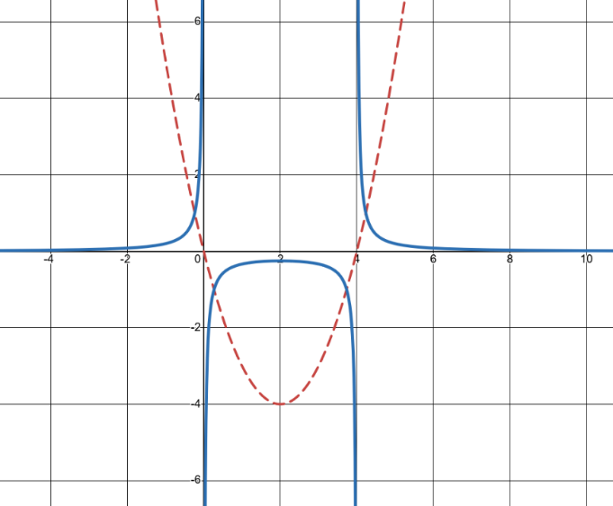
How could you get this sketch? You start by sketching bit bits you know: the two vertical asymptotes and the point $\left(2, -\frac{1}{4}\right)$. Then you need to use your common sense and possibly checking a few values to connect up what must be happening in the rest of it.
For example, realize that whenever $f\left(x\right)$ is negative, $\frac{1}{f(x)}$ is also negative. That means that you MUST get the upside down U shape between $x=0$ and $x=4$. If it were a wave (like tangent or cotangent have) or an up-facing U, we’d have positive y-values, which we know are impossible.
We also know the horizontal asmptote at $y=0$, so you know that as y-values remain positive (on the other sides of the vertical asymptotes), they must also be getting smaller toward 0.

